Tableau Project Solutions

It is essential for businesses to protect their workers' health and safety. In order to do this, a secure workplace must be created, together with the required instruction and safety gear. Putting employee health and safety first can

decrease accidents, boost job satisfaction, and enhance organizational effectiveness.

The following information relates to the health and safety at each of XYZ's four offices.

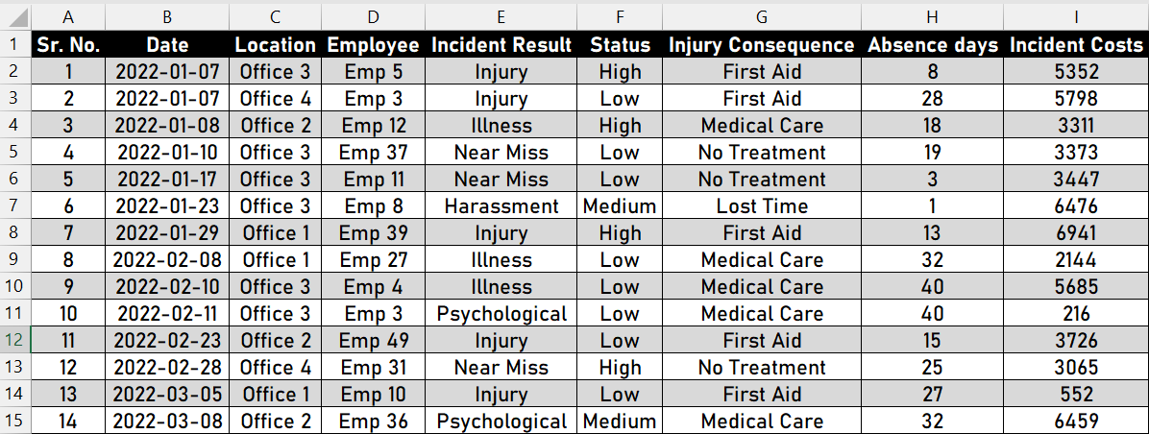

XYZ health & safety data of four offices

**Visual Insights**

* 1. 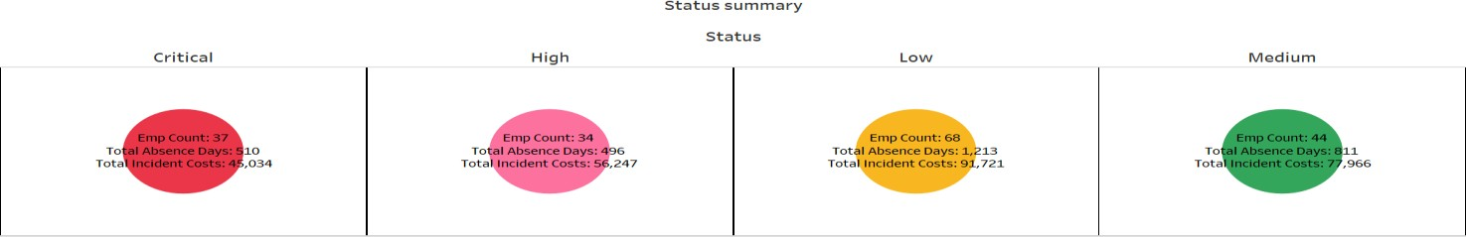Create number cards for status summary-wise total employee, total absence, and total incident costs

Like:

**Step 1**: Drag the field “Status” into the columns area.

**Step 2**: Drag the field “Employee” into the Label (Marks cards)

**Step 3**: Drag the field “Status” into the Color (Marks cards)

**Step 4**: Drag the field “Absence days” into the Label (Marks cards)

**Step 5**: Drag the field “Incident Costs” into the Label (Marks cards)

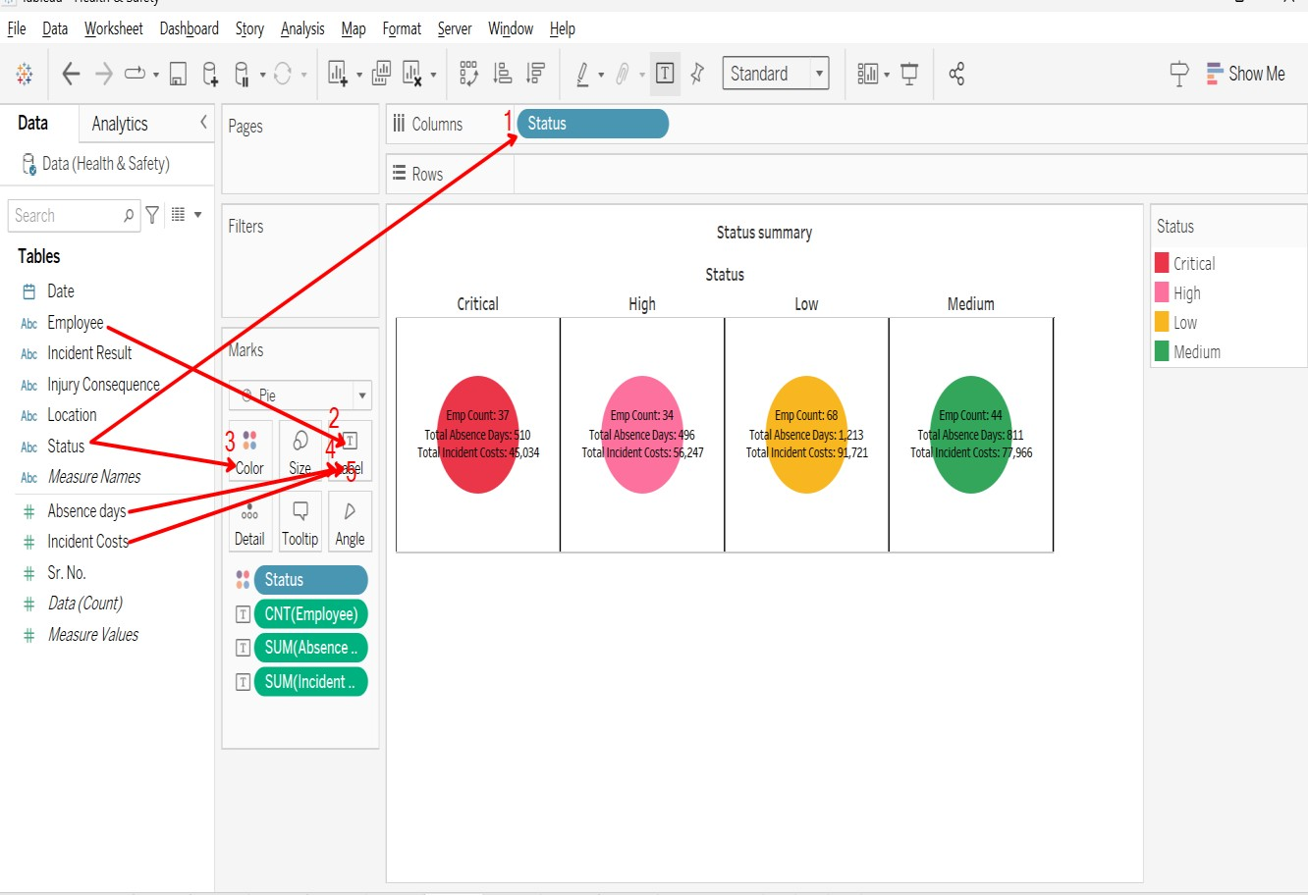

* 1. 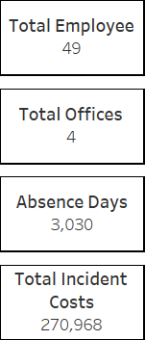Create cards for total employees, offices, absence days, and incident costs.

Like:

**Step 1**: Drag the Employee field into the text **Step 2**: Click on the text then align “Center” **Step 3**: Entire View

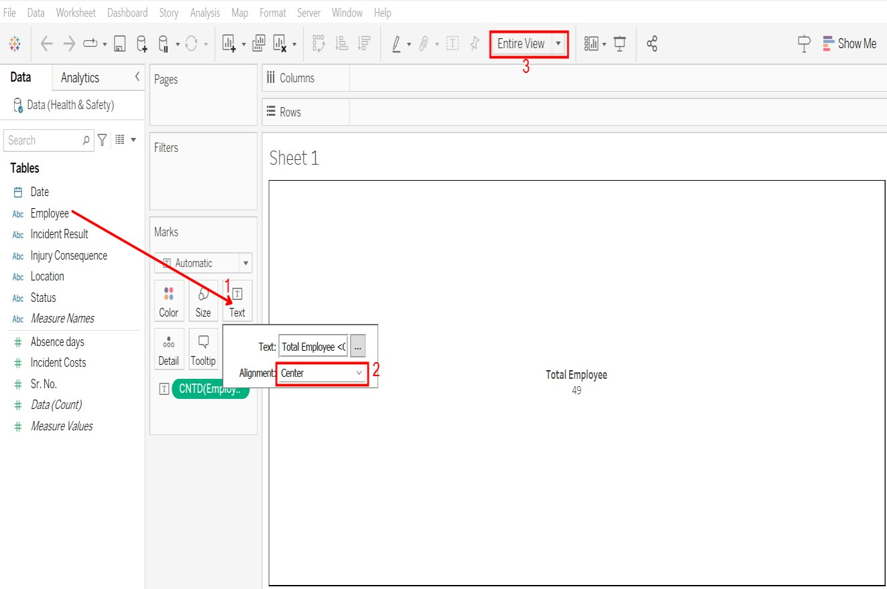

* 1. 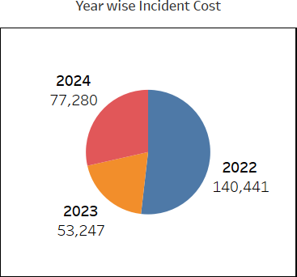Create a pie chart for year-wise incident costs.

Like:

**Step 1**: Drag the field “Date” into the Color (Marks cards)

**Step 2**: Drag the field "Date” into the Label (Marks cards)

**Step 3**: Drag the field “Incident Costs” into the Size (Marks cards) **Step 4**: Drag the field “Incident Costs” into the Label (Marks cards) **Step 5**: Drag the field “Incident Costs" into the Angle (Marks cards)

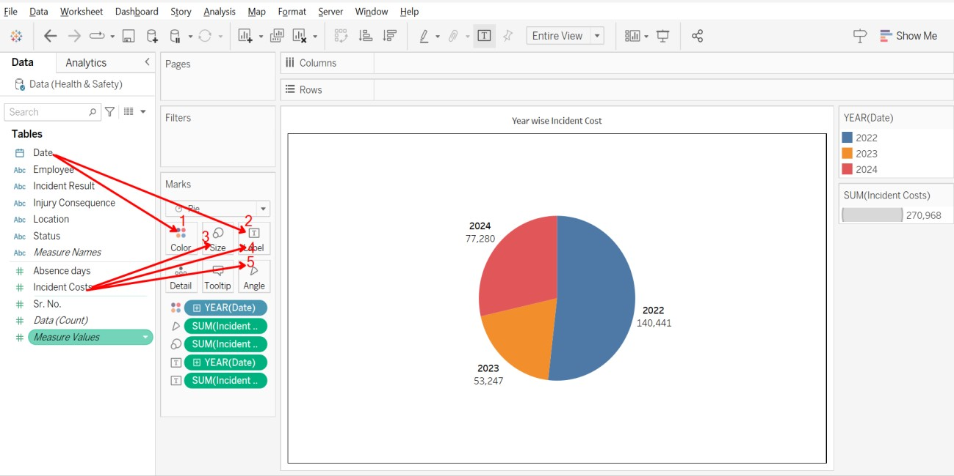

* 1. Create a table for Inquiry Consequences with total absence days and incident costs.

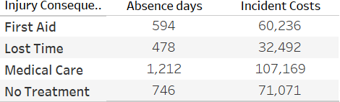

Like:

**Step 1**: Drag the field “Injury Consequence” into the rows area. **Step 2**: Drag the field “Measure Values” into the Text (Marks cards) **Step 3**: Drag the field “Measure Names” into the Columns area.

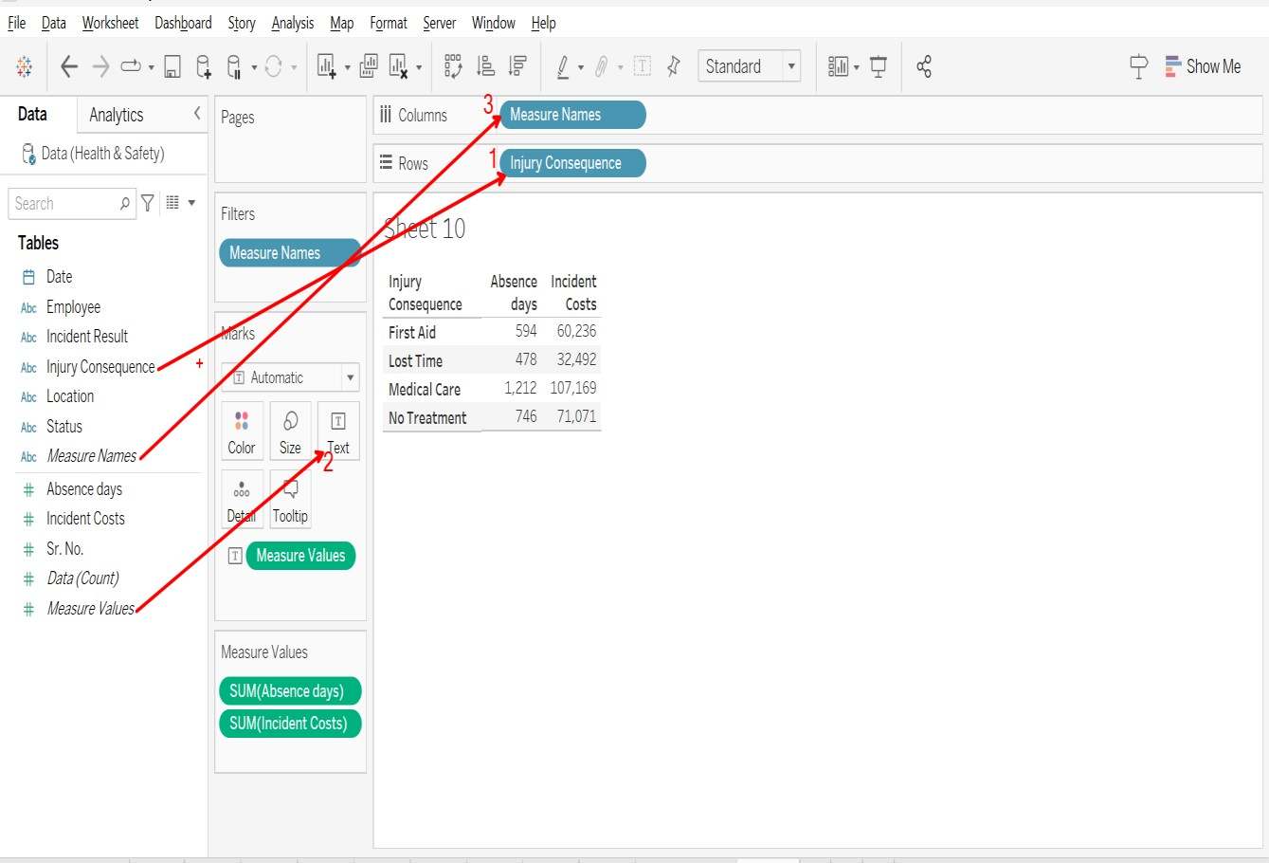

* 1. Create a table for location-wise total absence days, count of employees, and total incident costs.

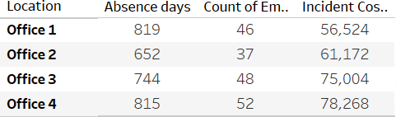

Like:

**Step 1**: Drag the field “Location” into the rows area.

**Step 2**: Drag the field “Measure Values” into the Text (Marks cards)

**Step 3**: Drag the field “Measure Names” into the Columns area.

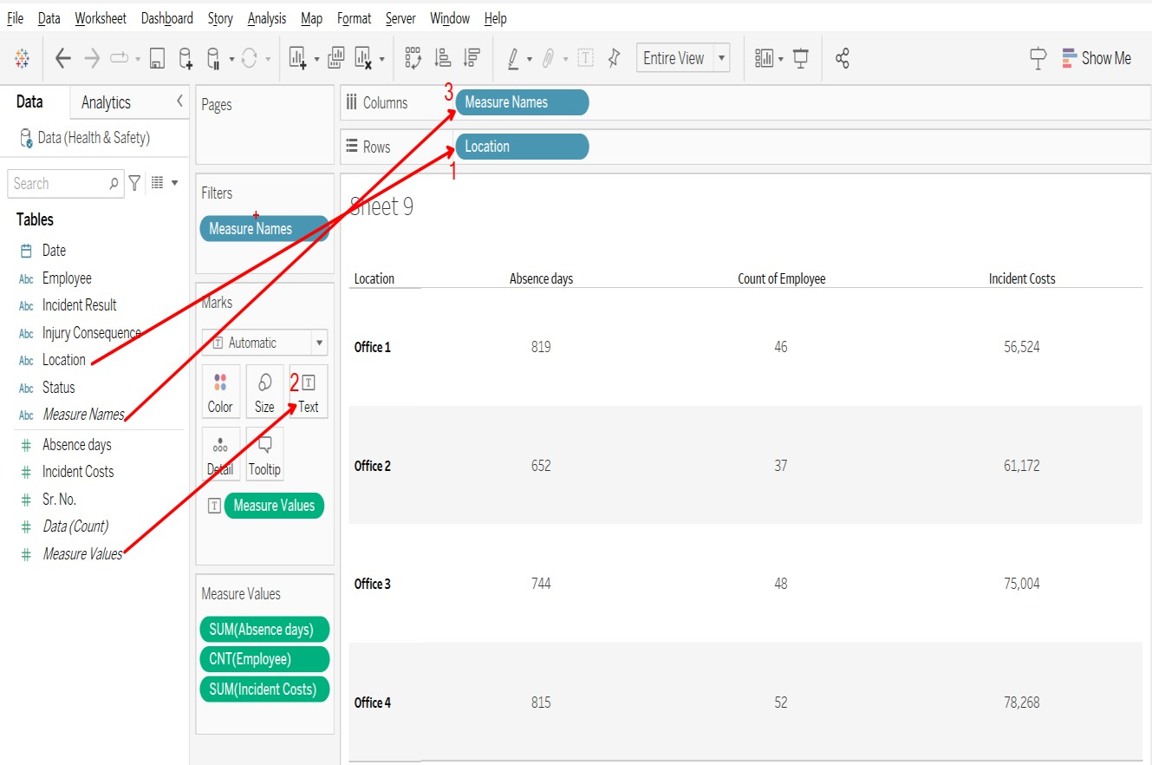

* 1. Create a combination chart for incident results

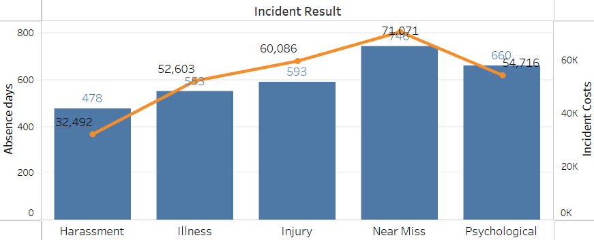

Like:

**Step 1**: Drag the field “Incident Result” into the columns area.

**Step 2**: Drag the field “Absences Days” into the Rows area.

**Step 3**: Drag the field “Incident Costs” into the Rows area.

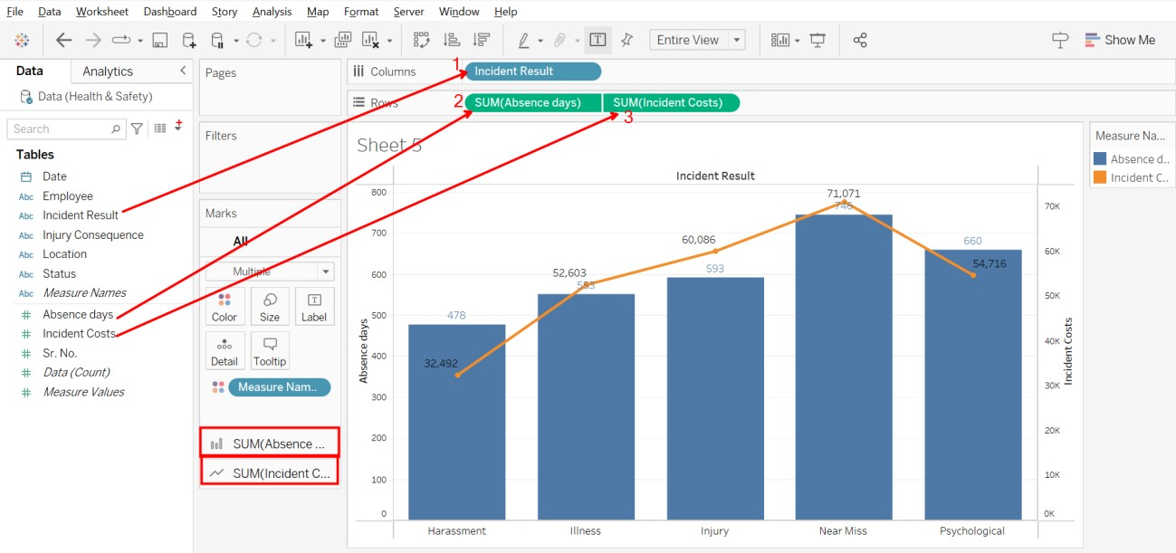

Final Dashboard